Pig script contents:

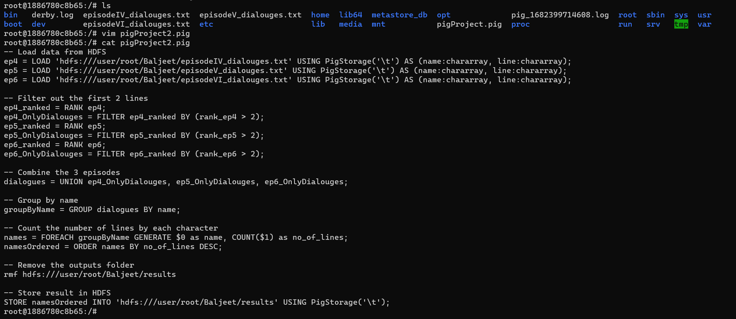

Execute Pig file:



Pig script got completed:

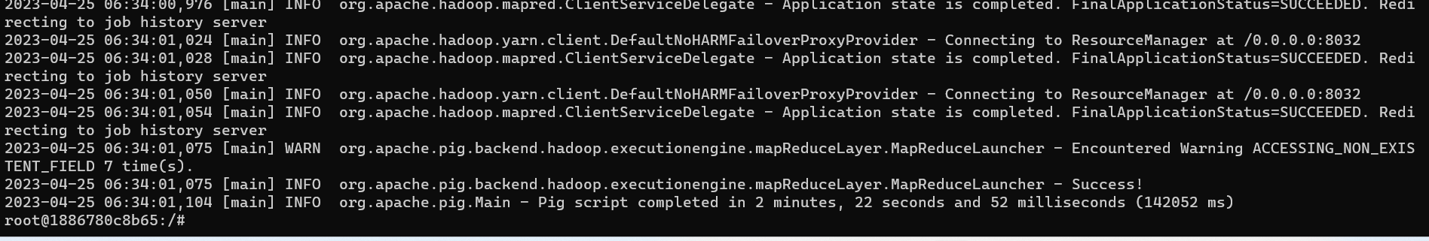

Results folder:

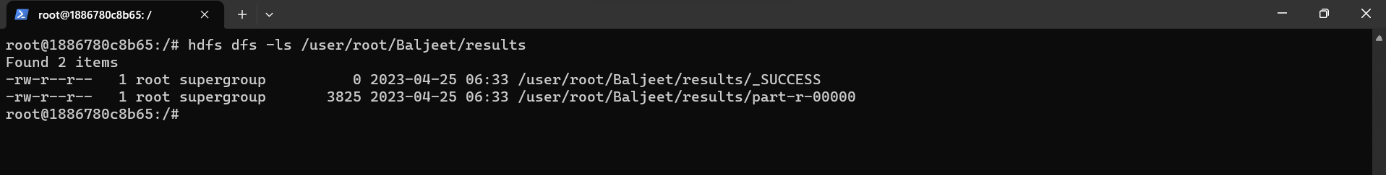

Contents of results:

